Week 2

**Roll No: 241801318**

**Name: Vishruthi KS**

**Q1)** Many people think about their height in feet and inches, even in some countries that primarily use the metric system. Write a program that reads a number of feet from the user, followed by a number of inches. Once these values are read, your program should compute and display the equivalent number of centimeters.

**Hint:**

One foot is 12 inches.

 One inch is 2.54 centimeters.

**Input Format**

 First line,read the number of feet.

 Second line, read the number of inches.

**Output Format**

In one line print the height in centimeters.

 Note: All of the values should be displayed using two decimal places.

**Sample Input 1**

 5 6

**Sample Output 1**

 167.64

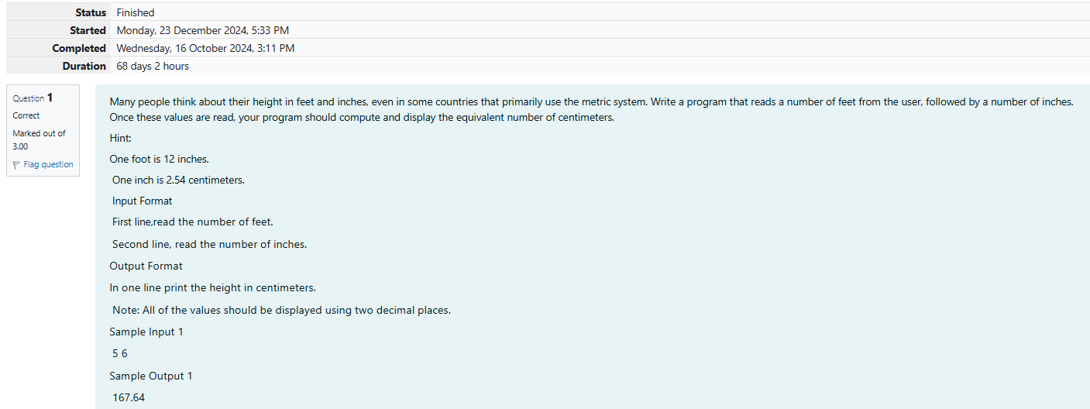

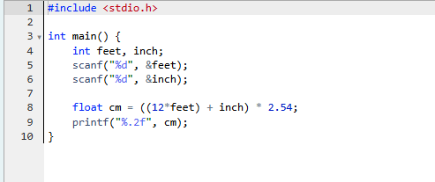

**Output:**

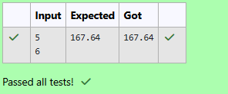

**Q2)** Create a program that reads two integers, a and b, from the user. Your program should compute and display: • The sum of a and b • The difference when b is subtracted from a • The product of a and b • The quotient when a is divided by b • The remainder when a is divided by b

Input Format

First line, read the first number.

 Second line, read the second number.

Output Format

First line, print the sum of a and b

Second line, print the difference when b is subtracted from a

Third line, print the product of a and b

Fourth line, print the quotient when a is divided by b

Fifth line, print the remainder when a is divided by b

Sample

Input 1 100 6

Sample Output

106 94 600 16 4

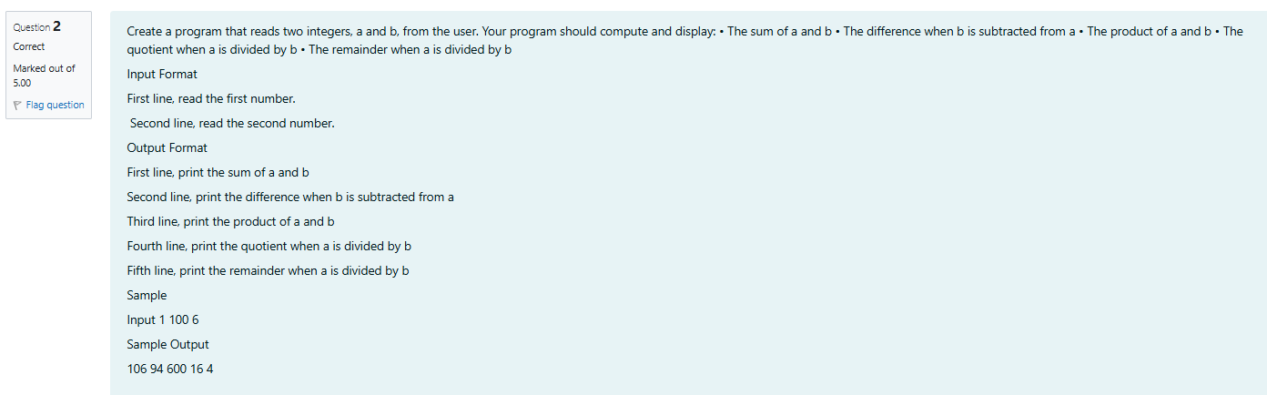

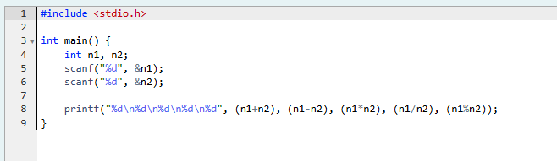

**Ouput:**

Output:



**Q3)** A bakery sells loaves of bread for $3.49 each. Day old bread is discounted by 60 percent. Write a program that begins by reading the number of loaves of day old bread being purchased from the user. Then your program should display the regular price for the bread, the discount because it is a day old, and the total price. Each of these amounts should be displayed on its own line with an appropriate label. All of the values should be displayed using two decimal places.

**Input Format**

Read the number of day old loaves.

**Output Format**

 First line, print Regular price: price

 Second line, print Discount: discount

Third line, print Total: total

**Note**: All of the values should be displayed using two decimal places.

**Sample Input 1**

10

**Sample Output 1**

Regular price: 34.90

Discount: 20.94

Total: 13.96

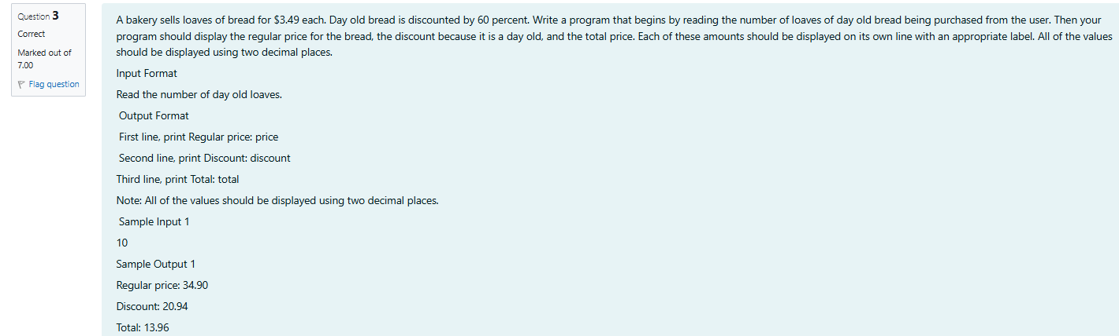

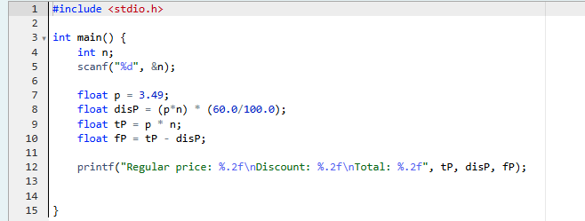

Output

**Week-02-02**

**Roll No:241801318**

**Name: Vishruthi KS**

**Q1)** Goki recently had a breakup, so he wants to have some more friends in his life. Goki has N people who he can be friends with, so he decides to choose among them according to their skills set Yi(1<=i<=n). He wants atleast X skills in his friends. Help Goki find his friends. ________________________________________

 INPUT

First line contains a single integer X - denoting the minimum skill required to be Goki's friend. Next line contains one integer Y - denoting the skill of the person

. ________________________________________

**OUTPUT**

 Print if he can be friend with Goki. 'YES' (without quotes) if he can be friends with Goki else 'NO' (without quotes).

 ________________________________________

**CONSTRAINTS**

1<=N<=1000000

1<=X,Y<=1000000

SAMPLE INPUT 1

 100 110

 SAMPLE OUTPUT 1

YES

SAMPLE INPUT 2

 100 90

**SAMPLE OUTPUT 2**

NO

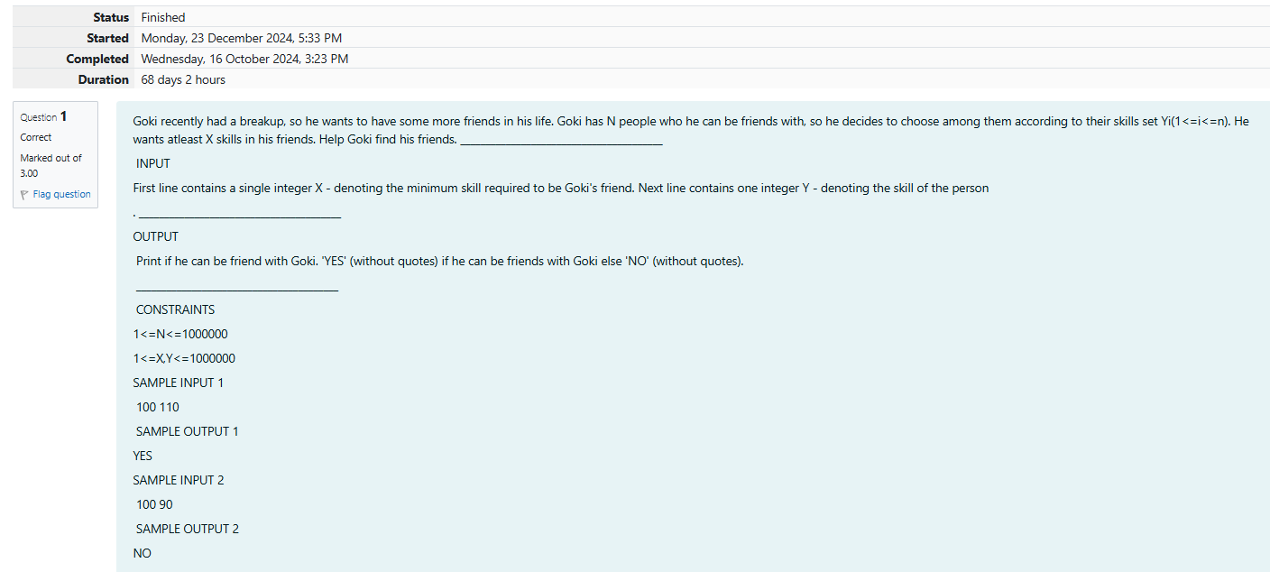

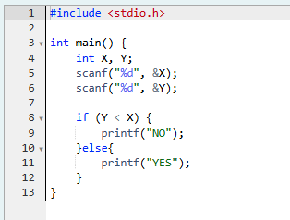

**Output:**

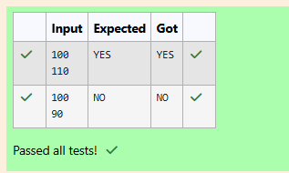

**Q2)** Before the outbreak of corona virus to the world, a meeting happened in a room in Wuhan. A person who attended that meeting had COVID-19 and no one in the room knew about it! So everyone started shaking hands with everyone else in the room as a gesture of respect and after meeting unfortunately everyone got infected! Given the fact that any two persons shake hand exactly once, Can you tell the total count of handshakes happened in that meeting? Say no to shakehands. Regularly wash your hands. Stay Safe.

Input Format

Read an integer N,the total number of people attended that meeting.

Output Format

Print the number of handshakes.

**Constraints**

0 < N < 106

**SAMPLE INPUT 1**

 1

**SAMPLE OUTPUT**

0

**SAMPLE INPUT 2**

 2

**SAMPLE OUTPUT 2**

1

Explanation Case 1: The lonely board member shakes no hands, hence 0. Case 2: There are 2 board members, 1 handshake takes place.

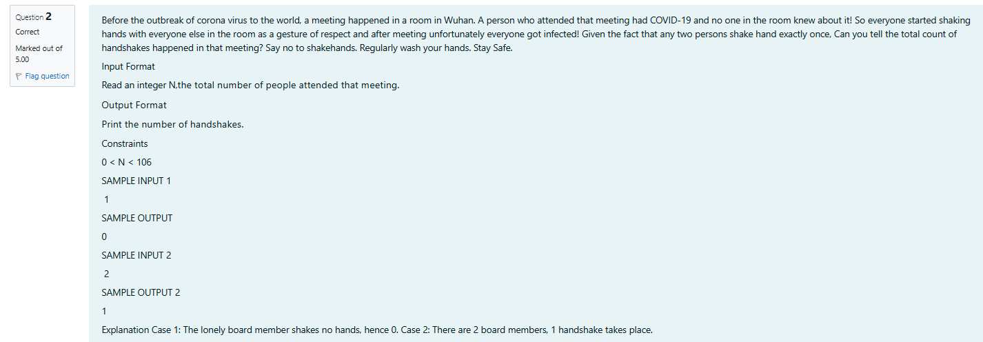

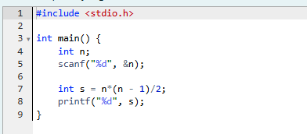

**Output:**

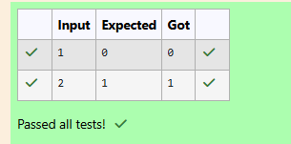

**Q3)** In our school days, all of us have enjoyed the Games period. Raghav loves to play cricket and is Captain of his team. He always wanted to win all cricket matches. But only one last Games period is left in school now. After that he will pass out from school. So, this match is very important to him. He does not want to lose it. So he has done a lot of planning to make sure his teams wins. He is worried about only one opponent - Jatin, who is very good batsman. Raghav has figured out 3 types of bowling techniques, that could be most beneficial for dismissing Jatin. He has given points to each of the 3 techniques. You need to tell him which is the maximum point value, so that Raghav can select best technique. 3 numbers are given in input. Output the maximum of these numbers.

**Input:**

Three space separated integers.

**Output:**

Maximum integer value

**SAMPLE INPUT**

 8 6 1

SAMPLE OUTPUT

 8

Explanation Out of given numbers, 8 is maximum.

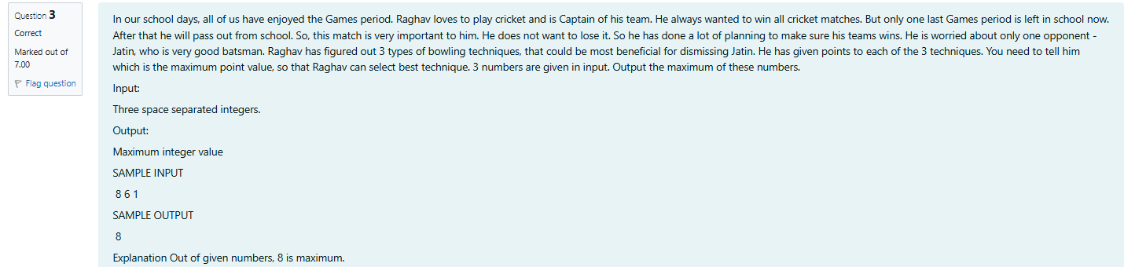

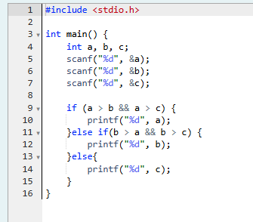

**Output:**

